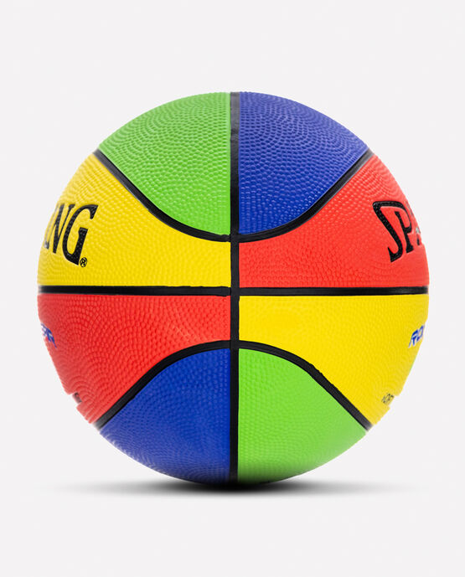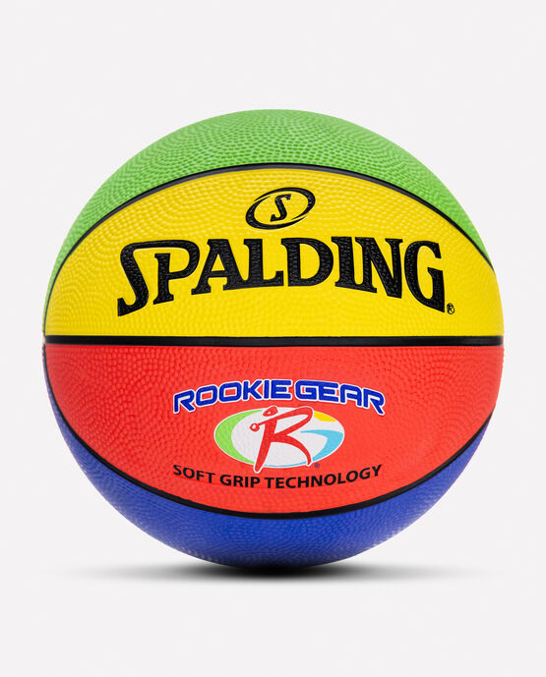

SPALDING ROOKIE GEAR SOFT GRIP YOUTH BASKETBALL

Made with a lighter weight than standard youth basketballs, The Spalding Rookie Gear® SGT Youth Basketball helps kids build up their skills. The sponge rubber cover gives it a soft feel, and pebble graphics help with grip.

**DETAILS:**

* Youth: Size 5, 27.5"
* Soft Grip Technology cover
* 15% lighter to help develop technique
* Shipped inflated and game-ready
* Designed for indoor and outdoor play
* Backed by Spalding's Warranty